Lab 1 - Factory Resetting a Palo Alto 220 Firewall

Purpose: remove the existing console password on the firewall

Background Info: The firewalls already had an unknown password on them, and our job was to reset that password so that we could set our own password and configure the firewall.

Lab Summary:

We were able to get into maintenance mode and factory reset the firewall. This completely removed any existing configuration and passwords already on the firewall and allowed us to add configuration from scratch and our own password. An overwhelming majority of this lab was simply waiting for first, the firewall to come into management mode, and then for the configuration to be wiped.

Lab Commands:

Step 1: Immediately after plugging in the console cable from your computer to the firewall, console into the firewall through putty and type the word ‘maint’ (short for maintenance).

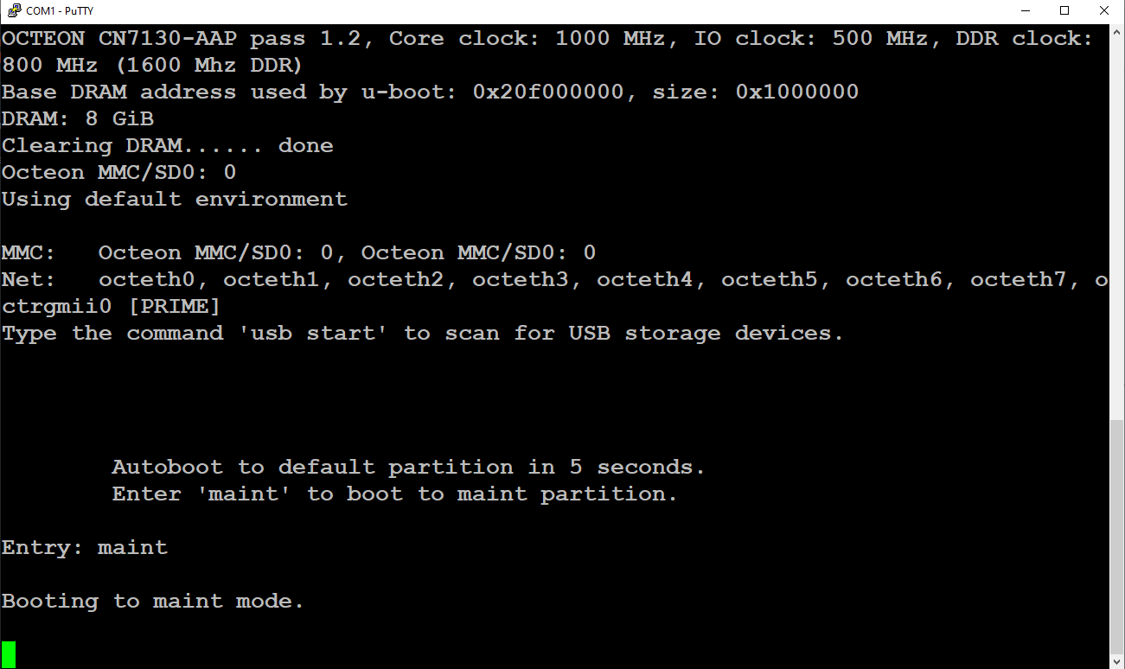

\*The console screen won’t show the word as you type it, but if done in time, it will start entering maintenance mode.’

Step 2: After entering maintenance, press enter to continue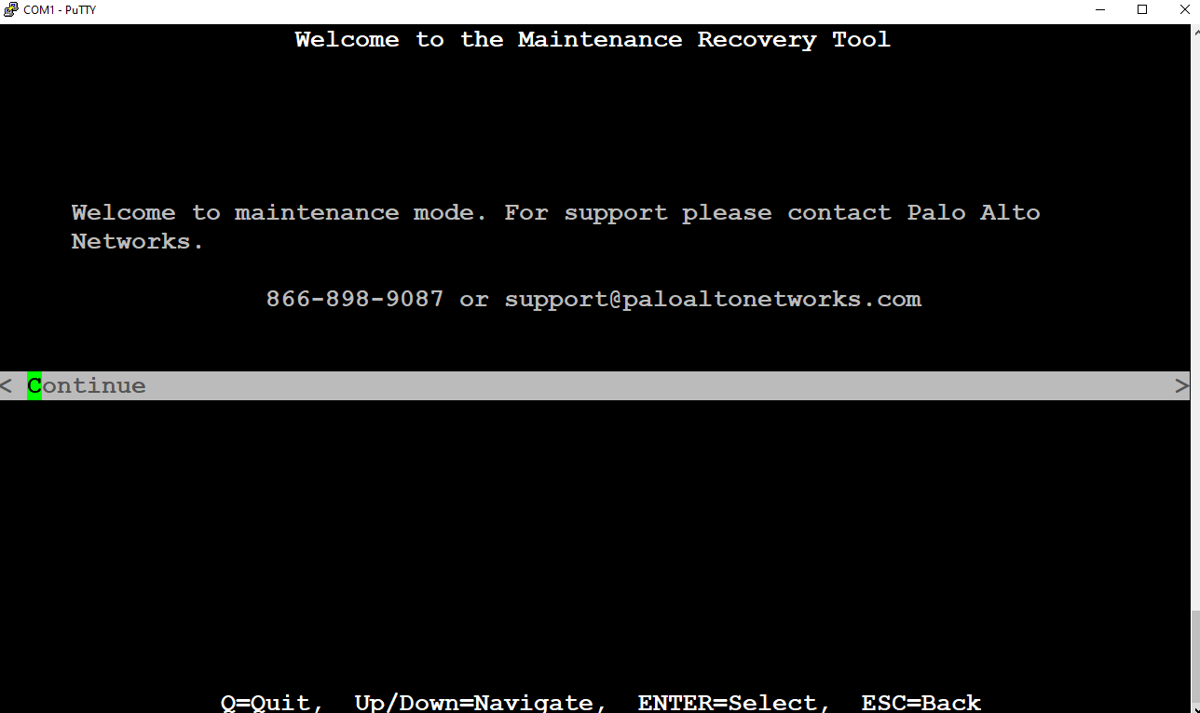

Step 3: Select Factory Reset

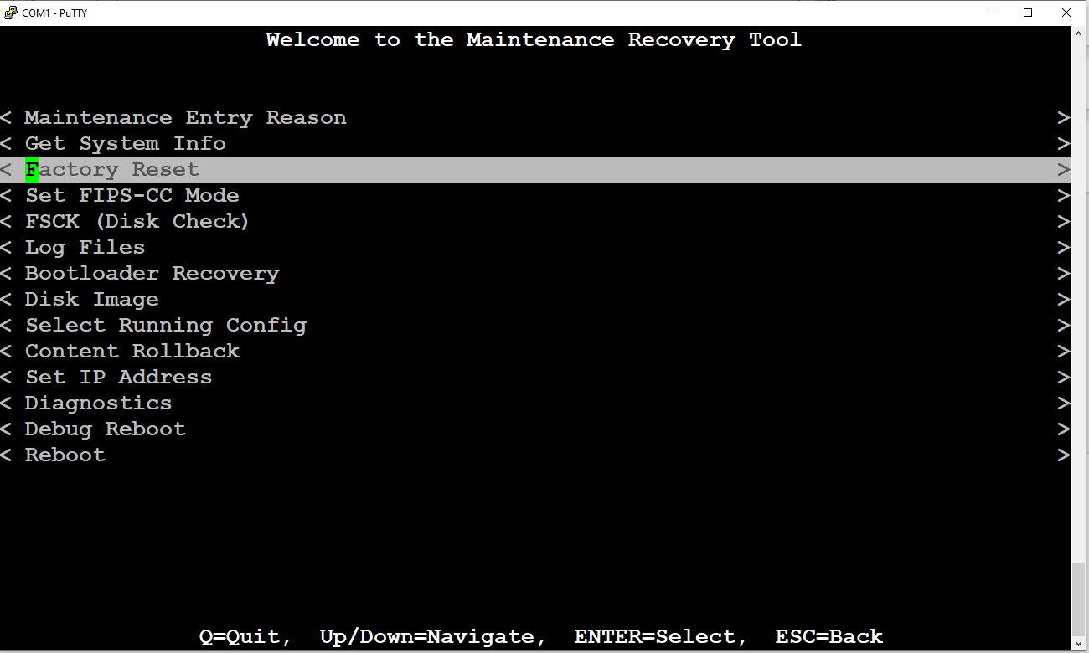

Step 4: Wait (patiently!) for the firewall to factory reset

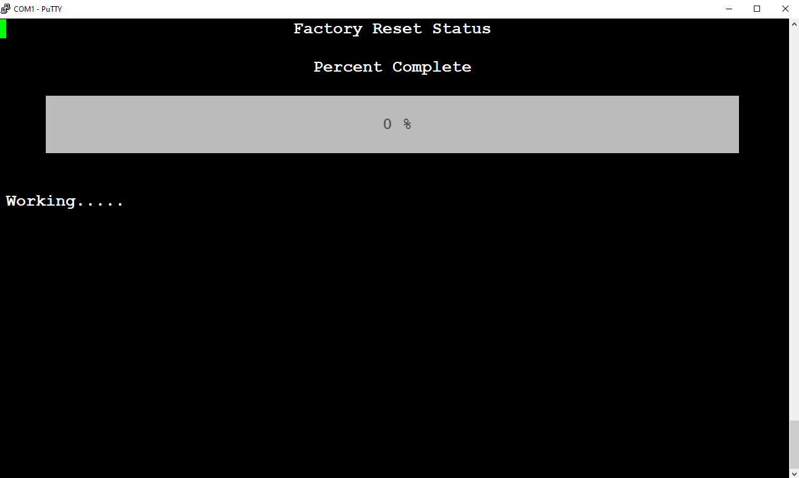

Step 5: After the firewall resets, you should see this screen. From here you should select reboot in order for the firewall to power cycle.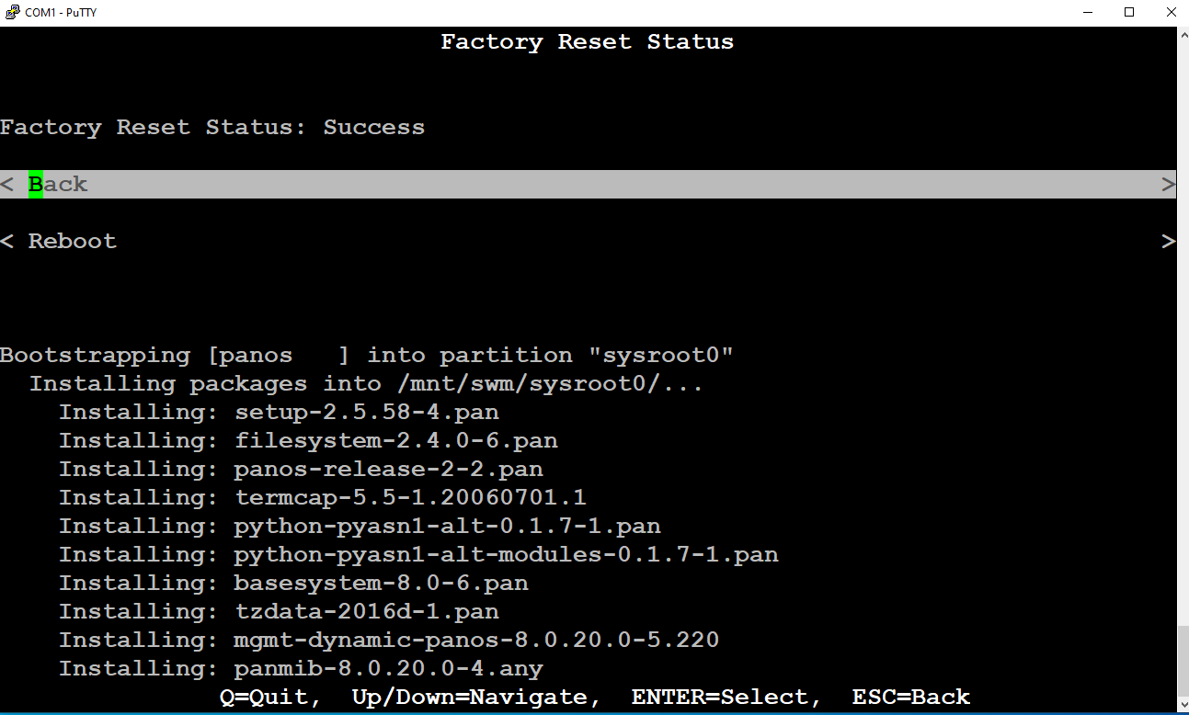

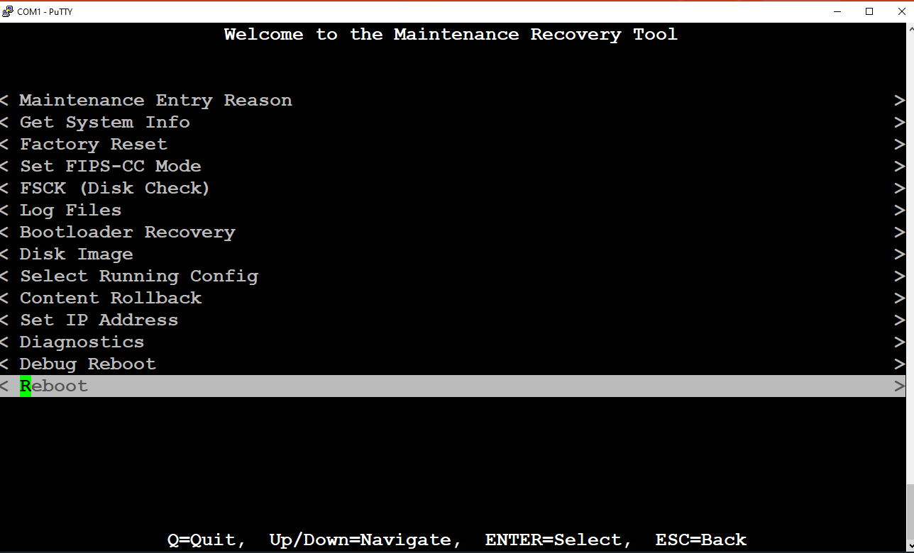

Step 5: After it power cycles, you will see a screen prompting a PA-HDF login. DO NOT do anything with that. Wait (again, Patiently!) for it to change to ‘PA-220 login:’

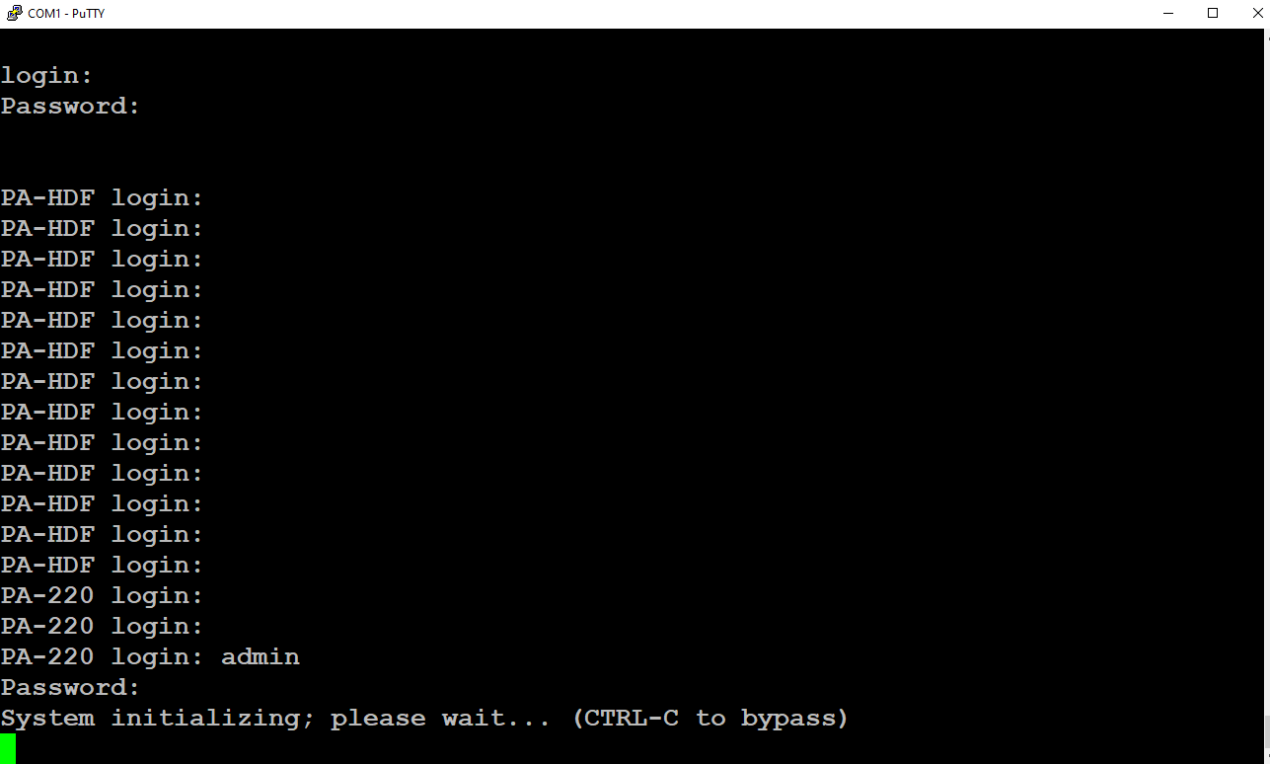

Step 6: The default admin is ‘admin’ and default password is “admin” as well. After you enter that in, you can set your new password. Meaning, you have successfully reset the password of the firewall!

Config: There are no configurations required for this procedure.

Problems: We tried to log into the firewall and change the password while it still displayed PA-220 HDF. We hoped to find a way to expedite the process however that is not possible and a massive waste of effort.

Conclusion: Knowing how to reset this firewall can be very useful in 2 situations:

1. You have made a crucial error in the configuration and need to wipe the configurations to start over and configure from scratch
2. Your firewall software gets corrupted, and you need to erase it from your firewall to revert you it to factory defaults

Teacher Signoff: